Abstract classes and Interfaces

# Problem statement:

Imagine there are 2 types of Professionals:-

1. Opthoprofessional (OpthoProfessional)
2. Cardiology Professional (CardioProfessional)

And they look like the one given in the below:-

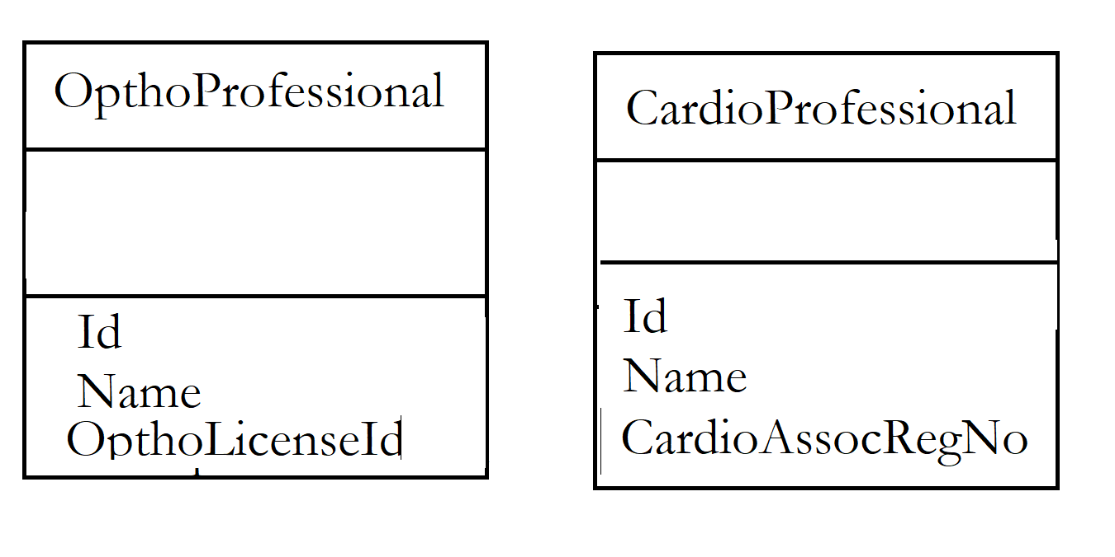

Can we store it in a common collection – say List<Professional>() and go about storing both OpthoProfessional and CardioProfessional instances and display accordingly ?

